Task 1

What is a thread and a Process?

A process is an independent program in execution. It has:

Its own memory space

Its own resources (e.g., open files, CPU time)

A thread is the smallest unit of execution within a process. Multiple threads can run in parallel within a single process.

Task 2

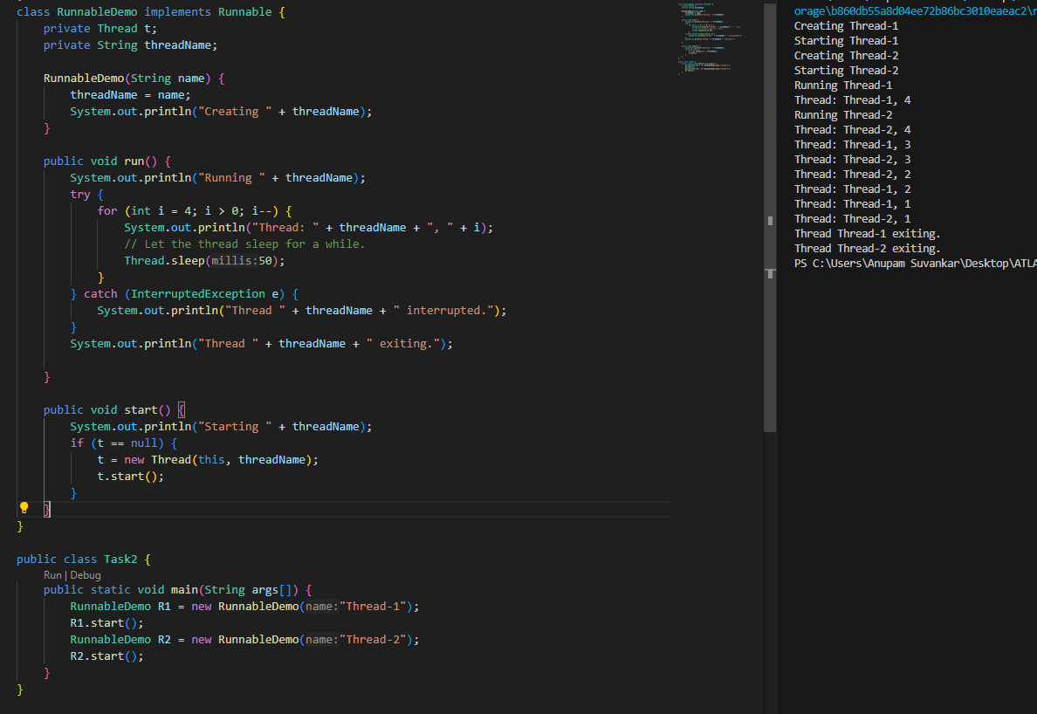

Task 3

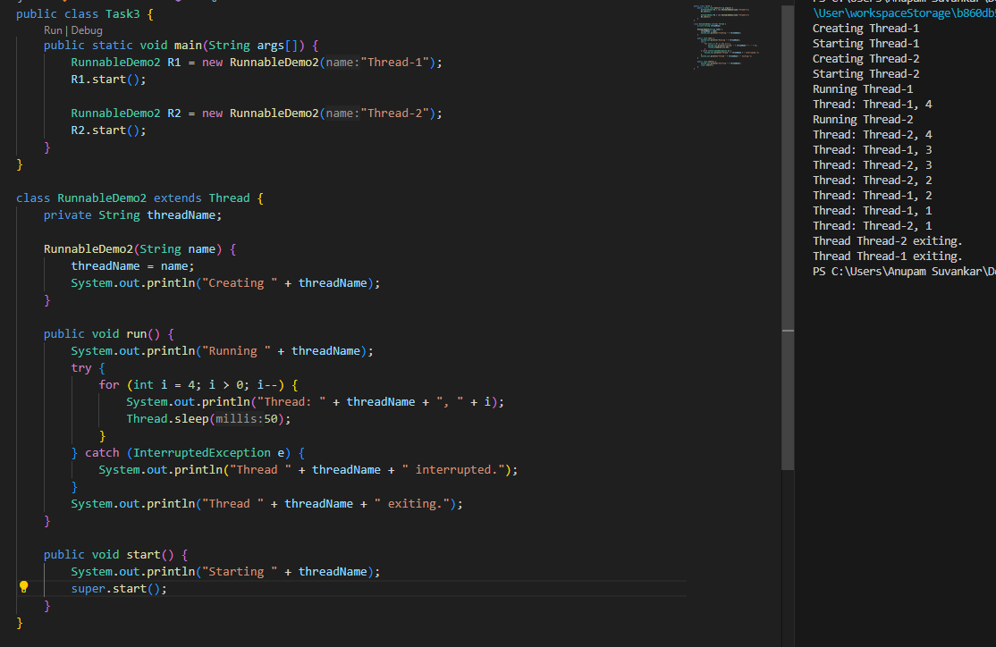

Task 4

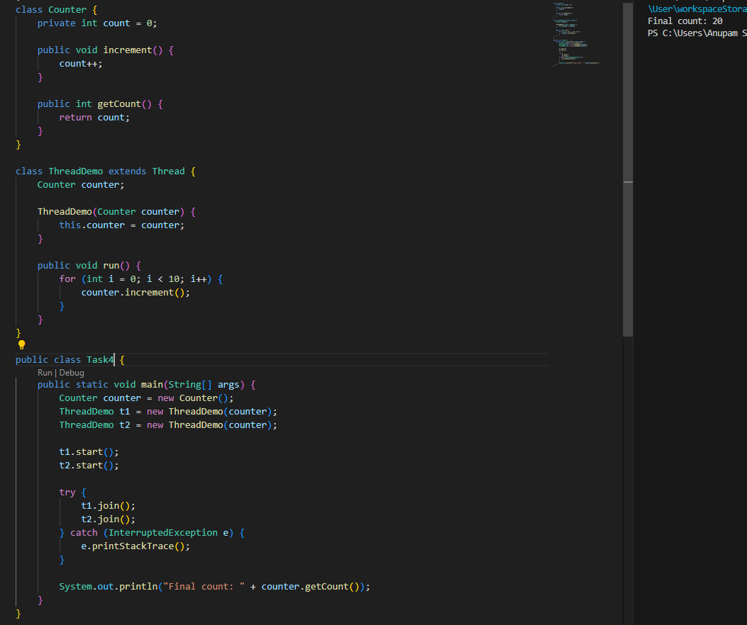

Task 5

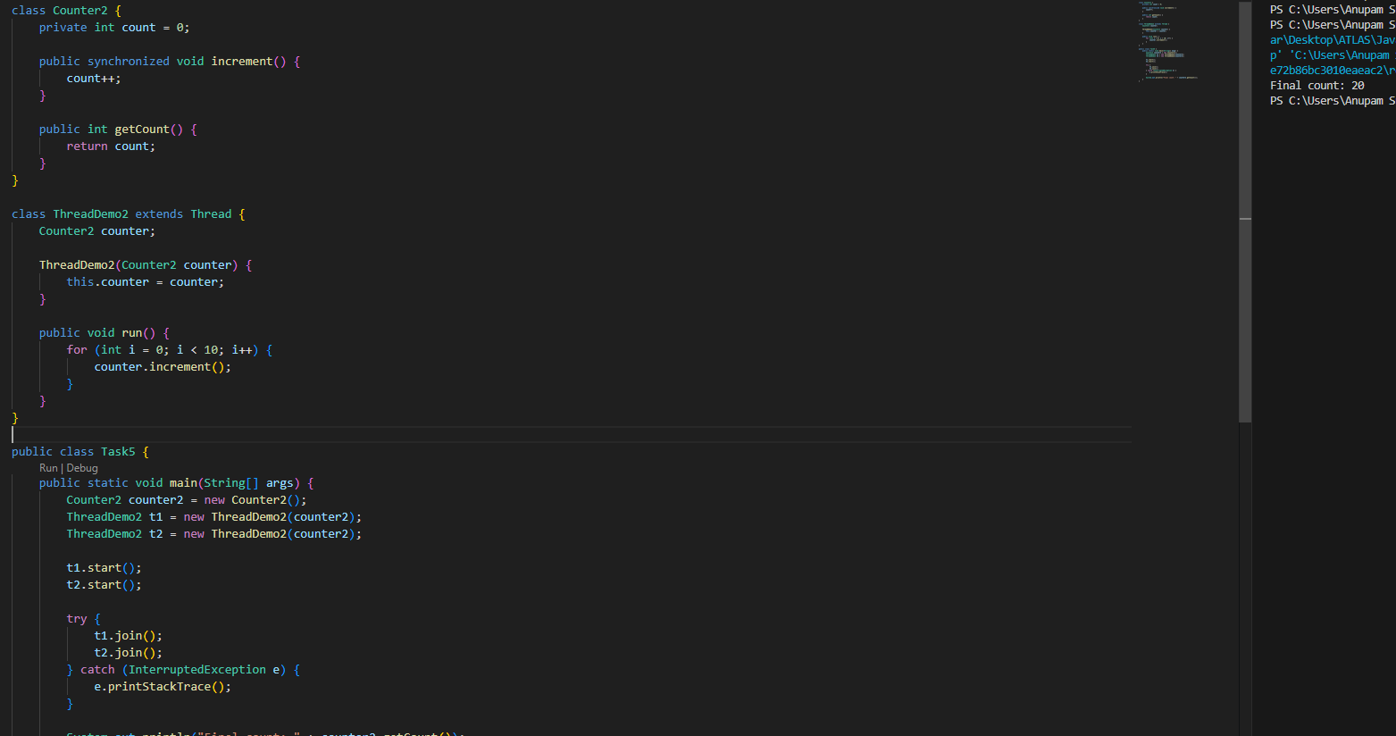

Task 6

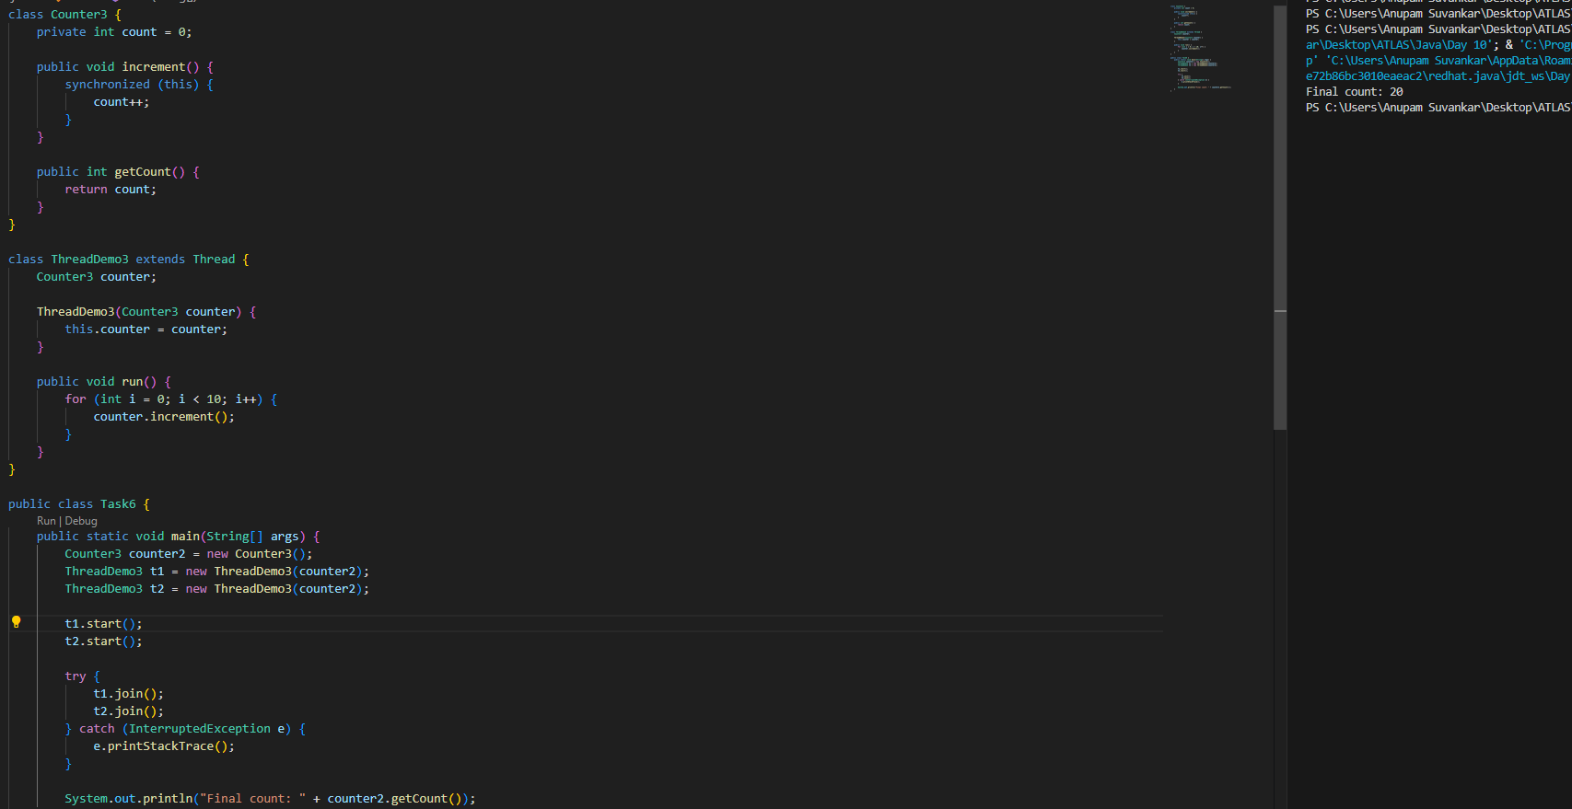

Task 7

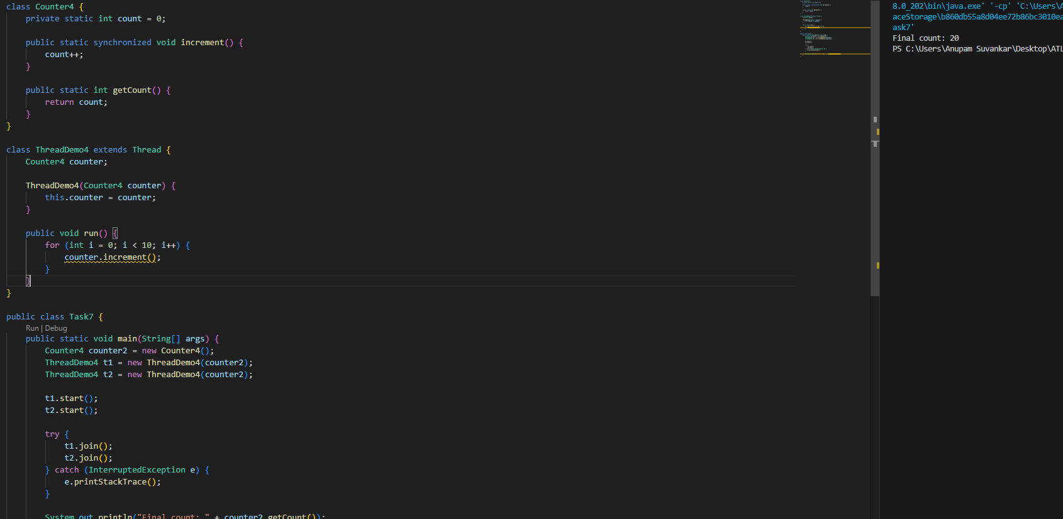

Task 8

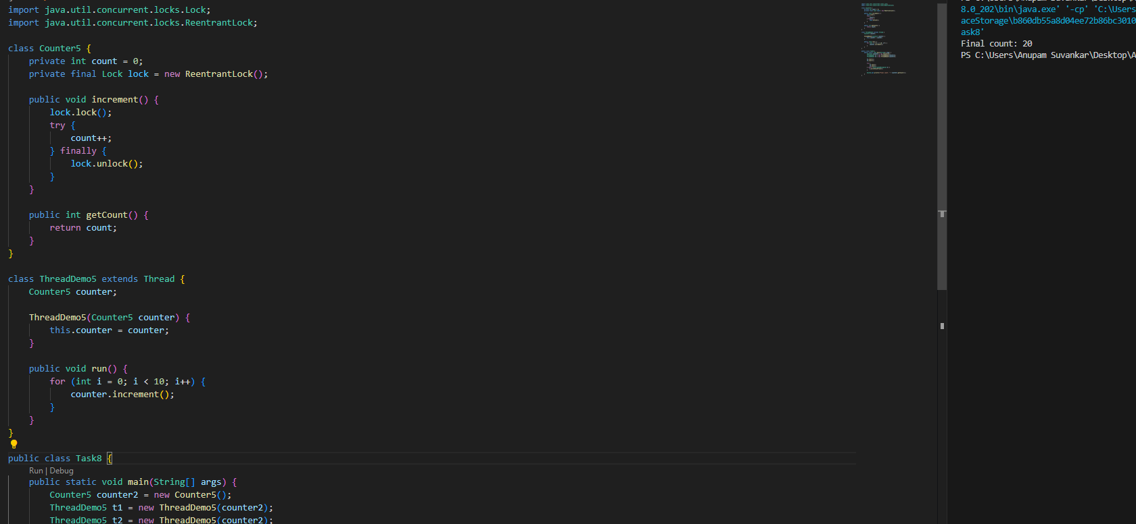

Task 10

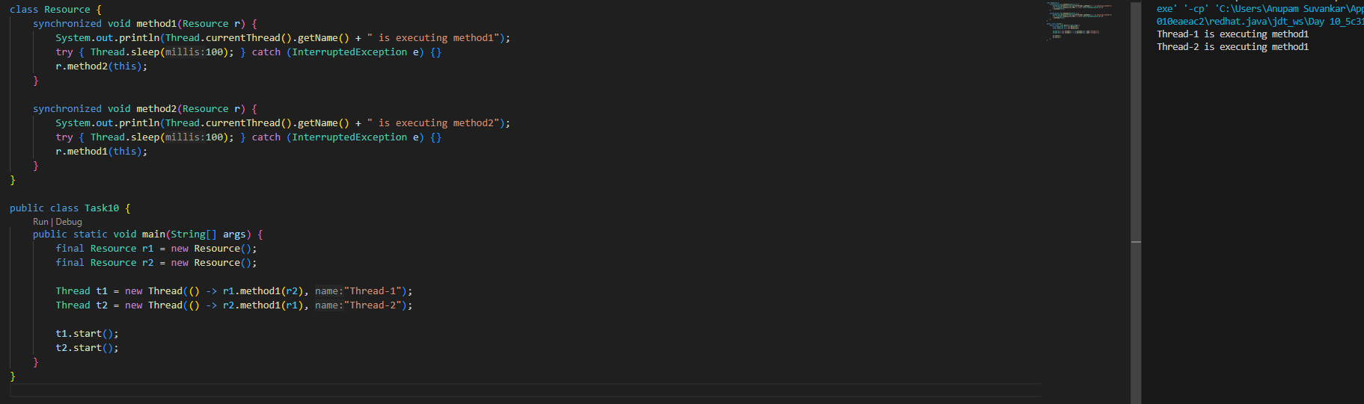

Task 11

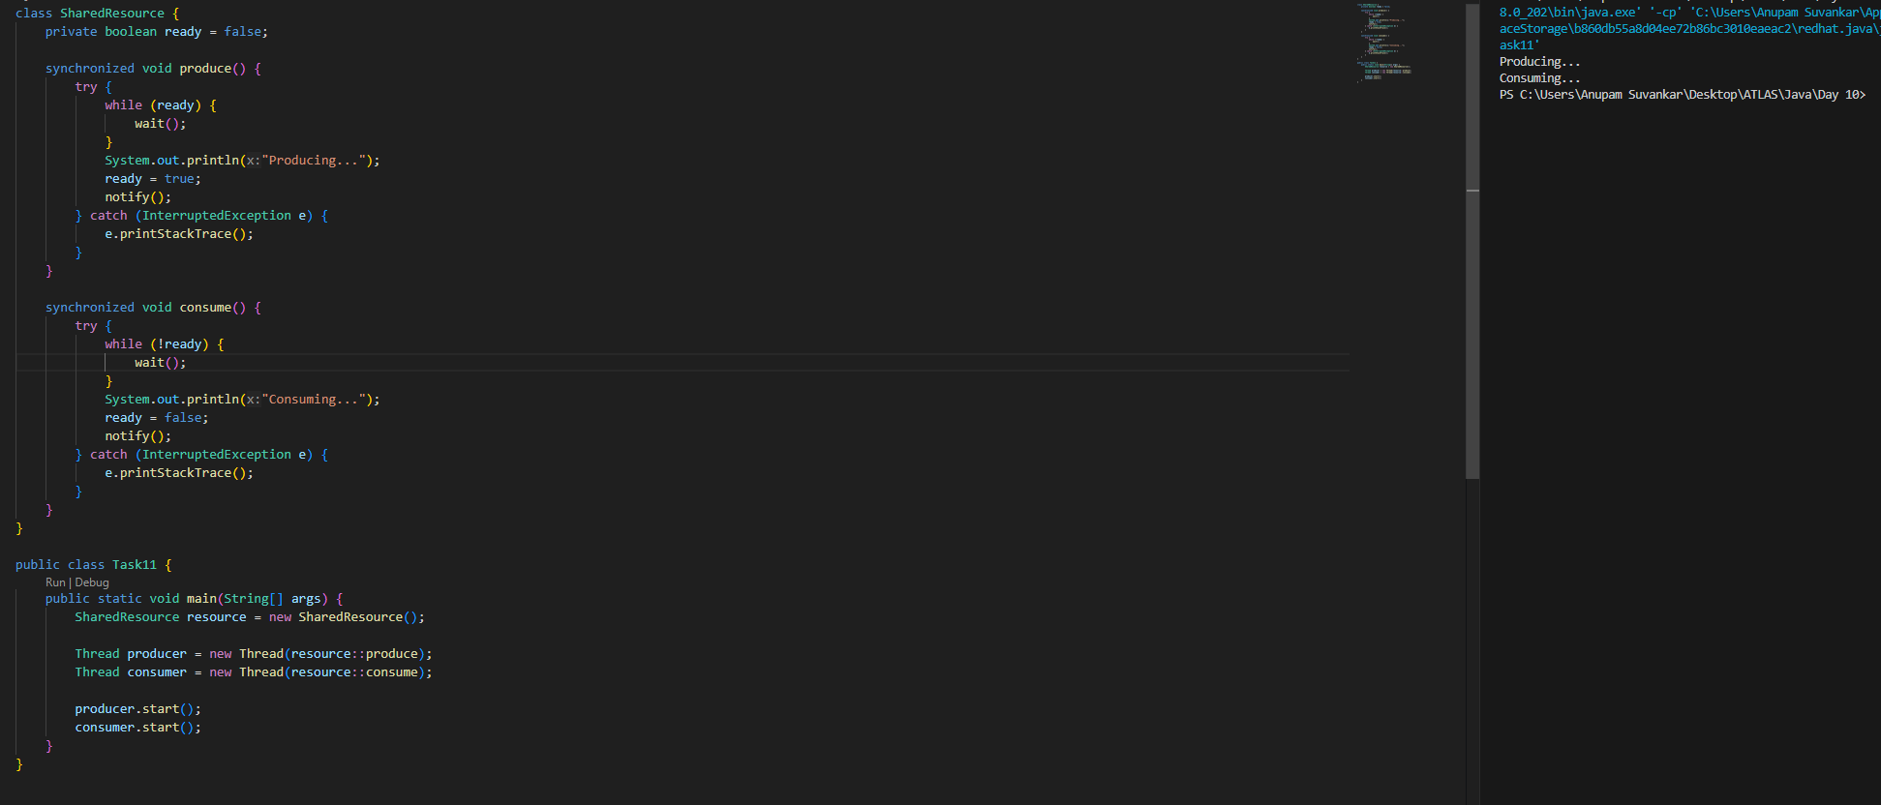

Task 12

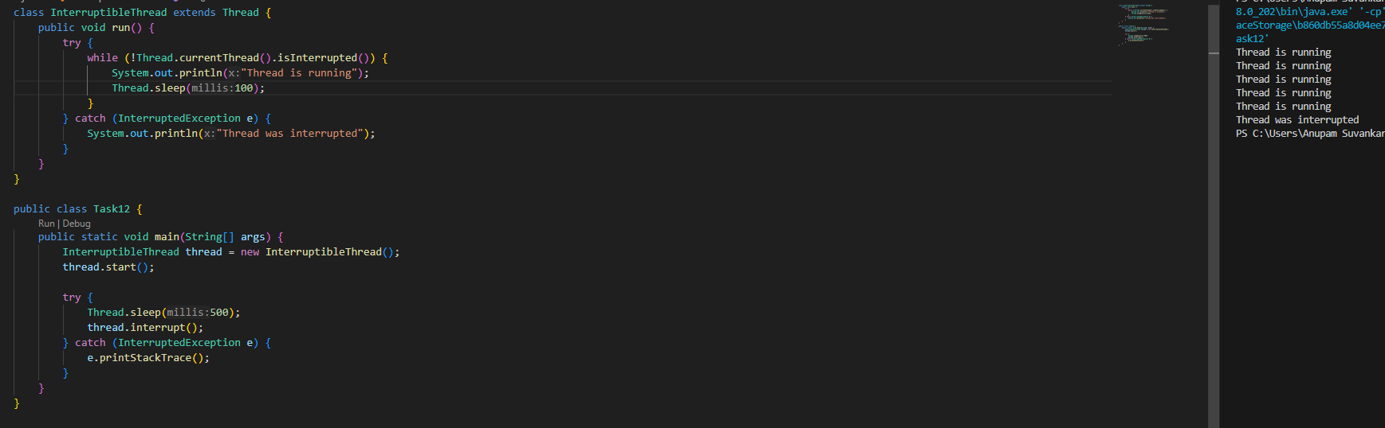

Task 14

What is Thread pool?

A Thread Pool is a concept used to manage a collection of reusable threads for executing tasks efficiently in multithreaded applications. Its is a group of pre-instantiated, idle threads that stand ready to execute tasks.

Task 15

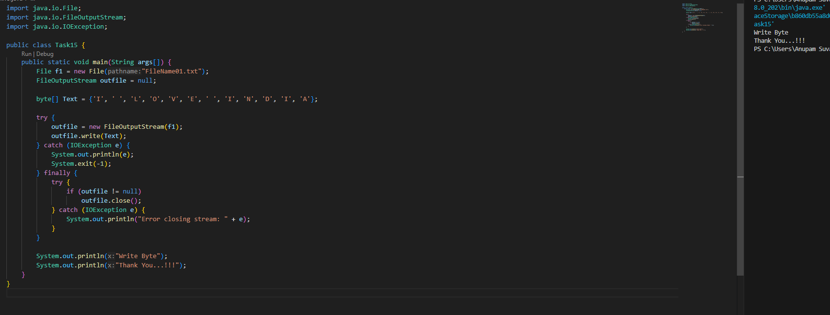

Task 16

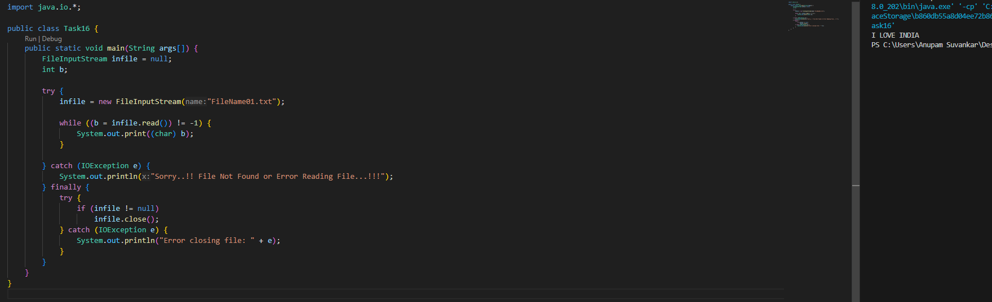

Task 17

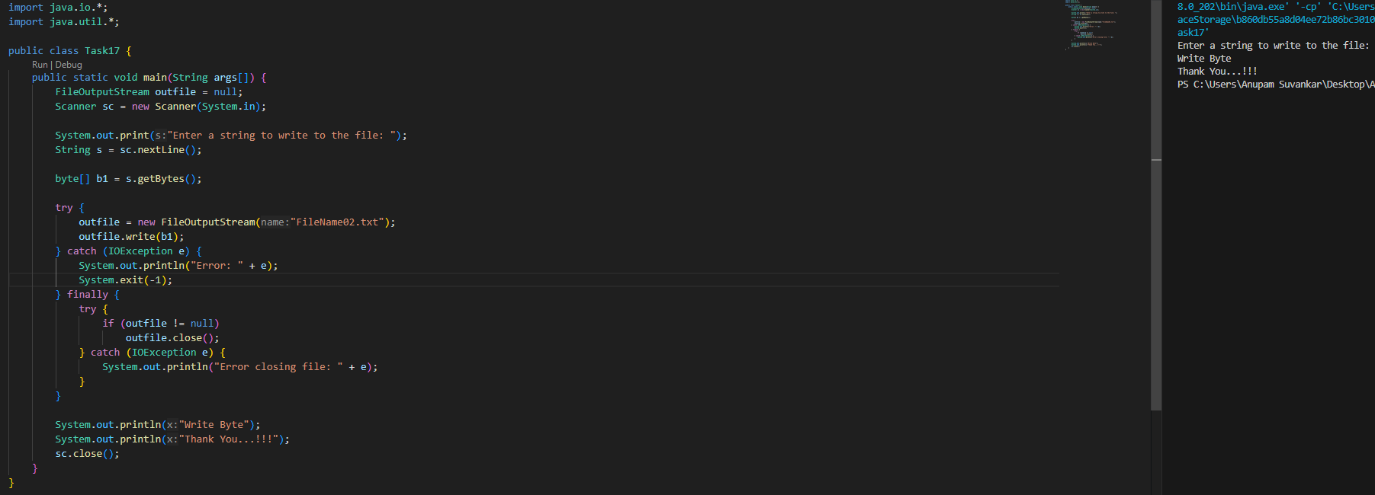

Task 18

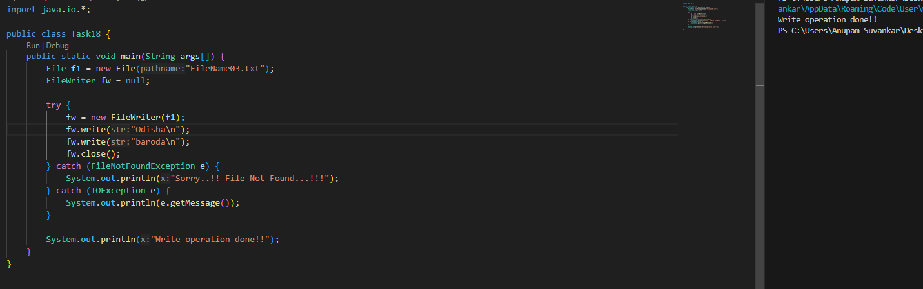

Task 19

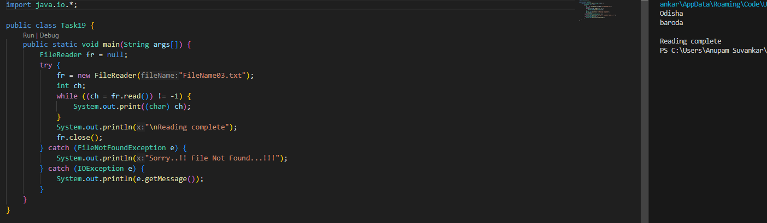

Task 20

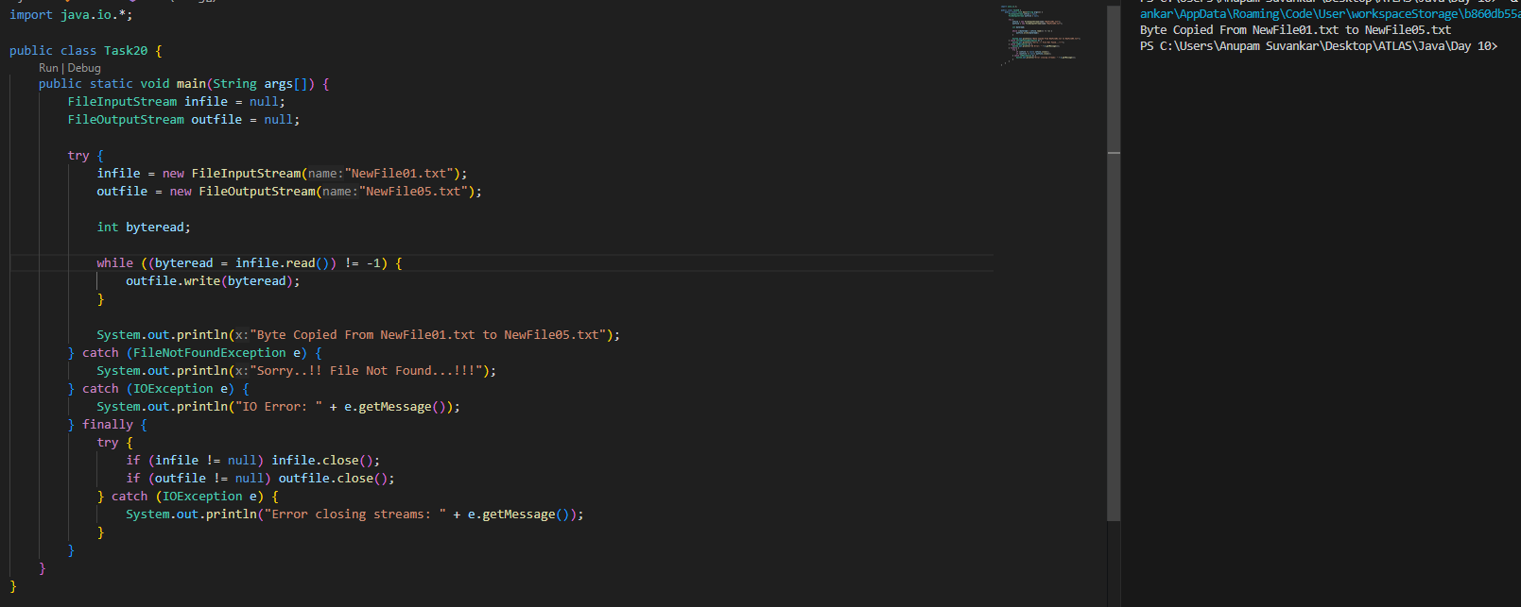

Task 21

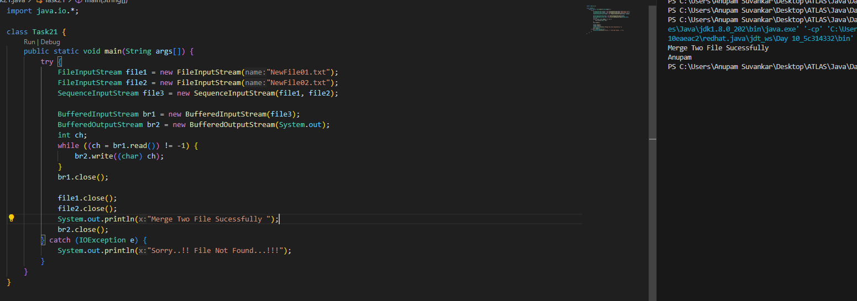

Task 22

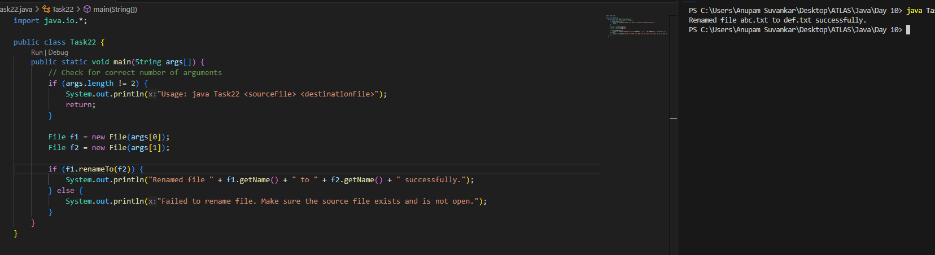

Task 23

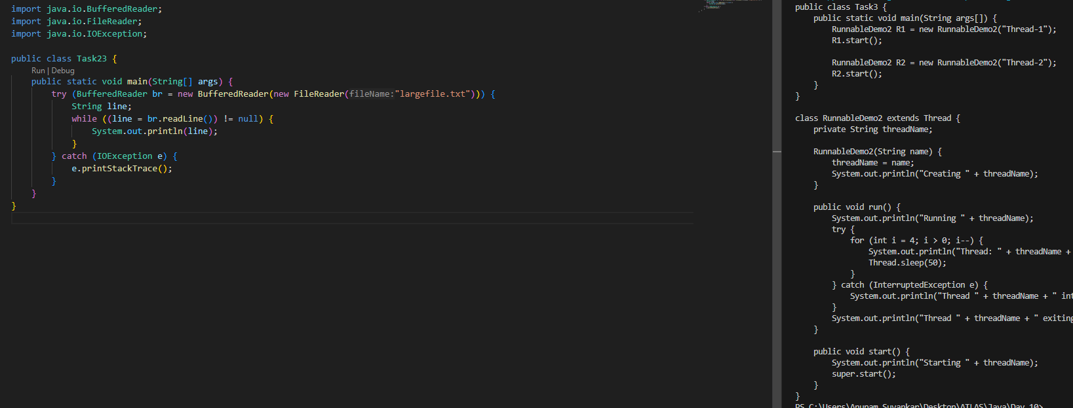

Task 24

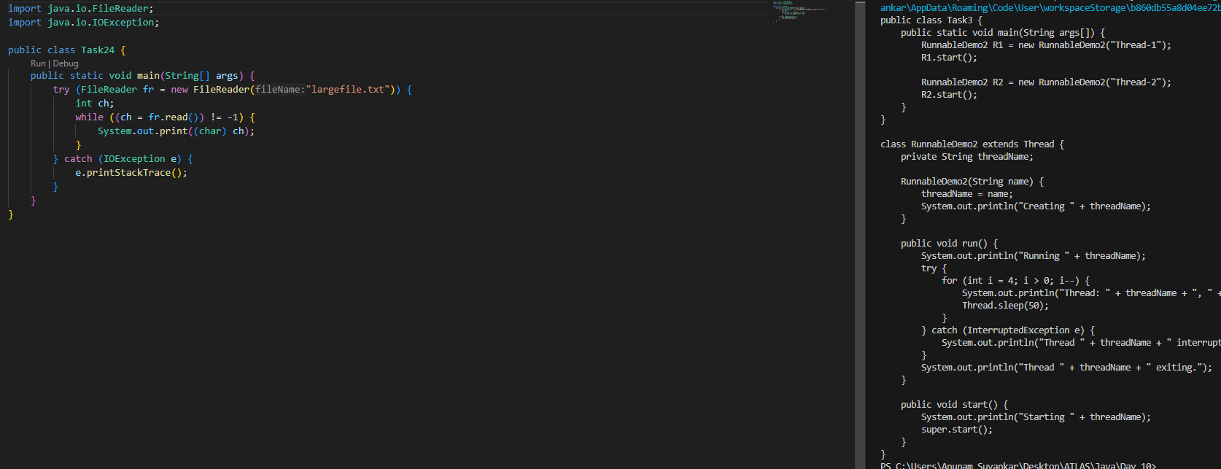

Task 25

